Hardware Design Final Project

**FPCAT – Battle Cat on FPGA**

Team 01

112062122 Chia Chin Hsieh 112062144 Sheng Wei Fan

Table of Contents:

1. Introduction 1

1.1 Motivation 1

1.2 Overview 1

2. Game Scene Architecture and Implementation Details 2

2.1 Start and Menu Scene 2

2.2 Play Scene 3

2.3 Win and Lose Scene 4

3. Game Material Design 5

3.1 Static Object Design 5

3.2 Character Design 6

3.2 Stage Design 6

4. Game Engine 7

4.1 Storage Protocols 7

4.2 Character FSM 7

4.3 Game State FSM 7

5. Graphics Rendering 8

5.1 Rendering Module Architecture 8

5.2 Layer Implementation 8

5.2.1 Statis Objects 8

5.2.2 Characters 8

6. Conclusion 9

6.1 Gameplay Demonstration 9

6.2 Comparison with Original Game 9

6.3 What We Learned 9

A. Appendix 10

A.1 Contribution 10

A.2 Python Tool - PNG to COE 10

# 1. Introduction

## 1.1 Motivation

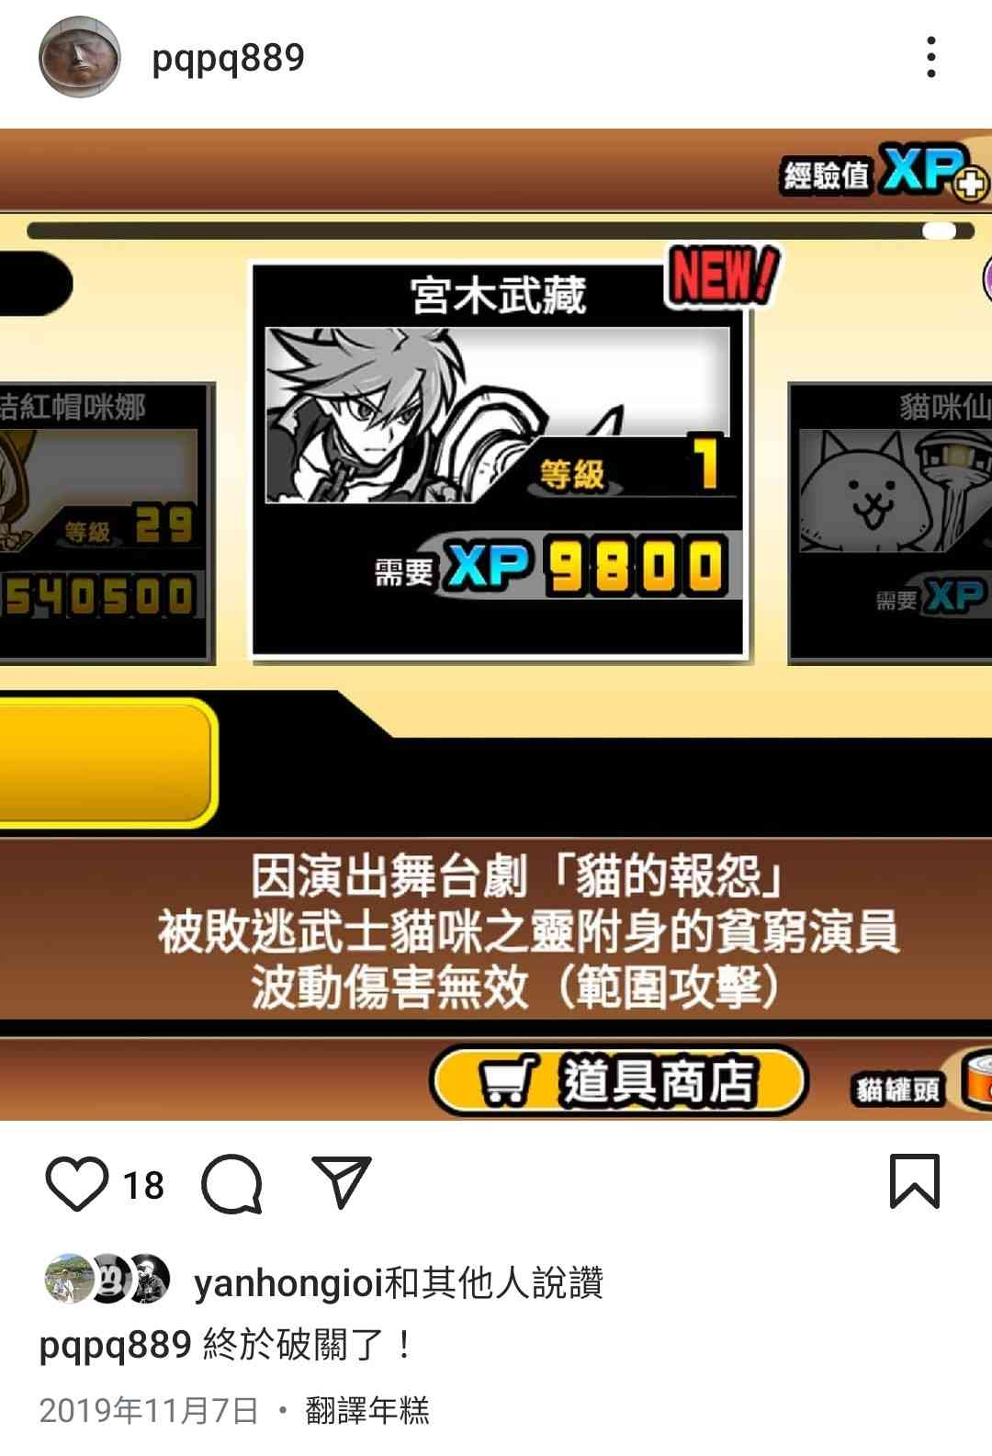The Battle Cats has been my favorite mobile game since I was in elementary school.

▲ Figure 1.1: An Instagram post of Chia Chin from 5 years ago

The stage and character designs are absolutely top-tier, even by today's standards. To share the fun of playing The Battle Cats with more people, we plan to create our own version of the game using FPGA. By showcasing this project on GitHub, we hope to demonstrate the game's appeal.

## 1.2 Overview

Our inspiration for the name "FPCAT" came from the integration of "FPGA" and "CAT". Our game requires players to use the mouse to operate. For screen signal transmission, we use VGA standard. The game begins with a **start scene**. After pressing the **start button**, the game transitions to the **menu scene**. each with designated enemies assigned to it.

In the **game scene**, players will have access to buttons for **cats**, **tower**, **purse**, and **pulse** (operated via an FPGA button). To **summon cats**, players must accumulate enough money, which can be earned over time. The **tower** can emit air cannon after it finishes charging. Players can also spend money to expand the **purse capacity** andspeed up the accumulation of money.

The goal is to destroy the enemy tower using the player's cats. If the player's cats succeed, the player wins. If the enemy destroys the player's tower, the player loses.

After triggering the **win scene** or **lose scene**, players can return to the **start scene** by clicking the mouse.

The figure below illustrates the module structure and relationships within our project. The signal painted in green represents the input of our Top module, while the signal painted in purple represents the output, and the remaining blue signals are important signals transmitted in out project.

▲ Figure 1.2: Top Abstract Block Diagram

This is a brief overview, with details discussed in the following chapters. For example, the renderer consists of four smaller modules: Render_Start, Render_Menu, Render_Play, and Render_WinLose. Each render module computes its own color code independently. This is why it needs to take input from the scene controller's output. The details will be covered in Chapter 5.

As for the Game Engine, we have represented it as a single block in the diagram. However, it is one of the most complex components we have implemented. It requires four different clocks and multiple signals to function properly. Additionally, it manages various gameplay elements, such as character states and game stats updates. Therefore, designing robust FSMs (Finite State Machines) is critical. We will elaborate on this in Chapter 4.

Finally, we have added some thoughtful touches to the picture and font components, which will be discussed in Chapter 3.

# 2. Game Scene Architecture and Implementation Details

This chapter introduces our game's scene design and its detailed components. The following sections will explain our implementation methods, challenges we encountered during development, and how we solved these problems.

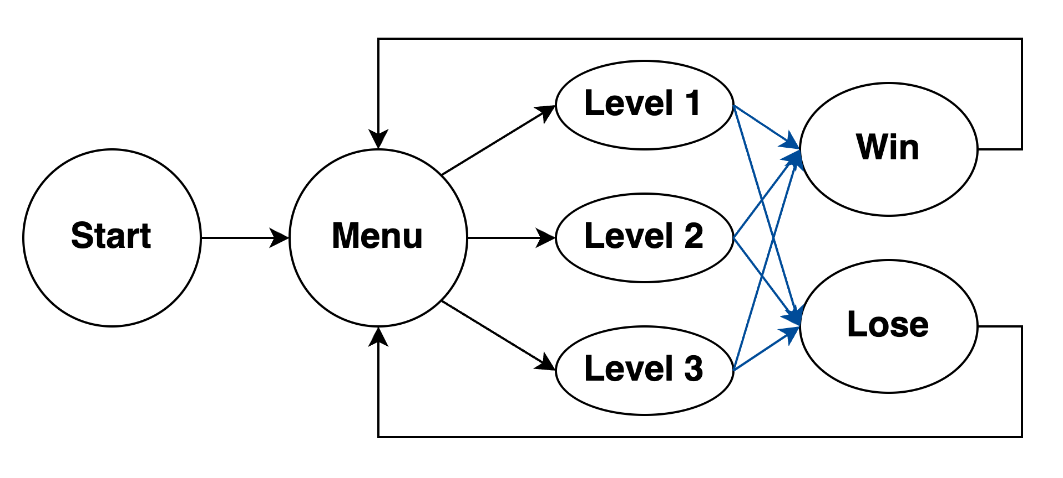First, here is our scene's FSM (Finite State Machine):

▲ Figure 2.1: Scene's FSM

The scene transitions marked in blue are the only ones triggered by the game engine itself, while all other transitions are initiated through button interactions. All mouse click detection implementations include **Debounce** and **One Pulse** mechanisms to ensure reliable input processing. For consistency, we used the clk_25MHz for these detections, which is the same clock signal used for VGA output and scene transitions.

## 2.1 Start and Menu Scene

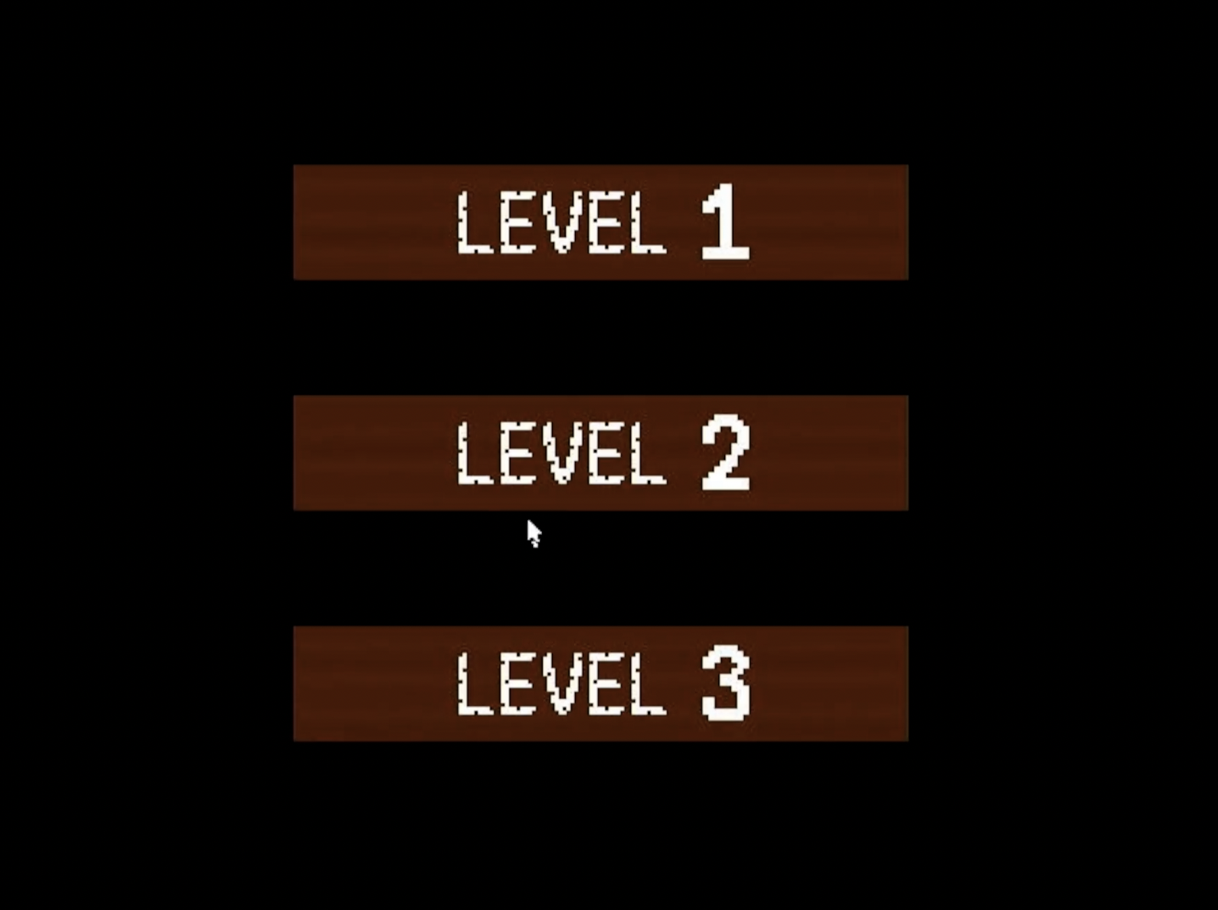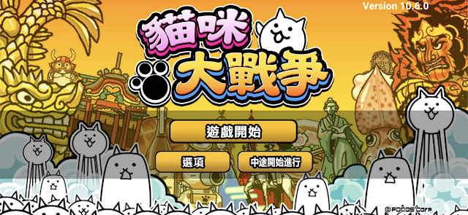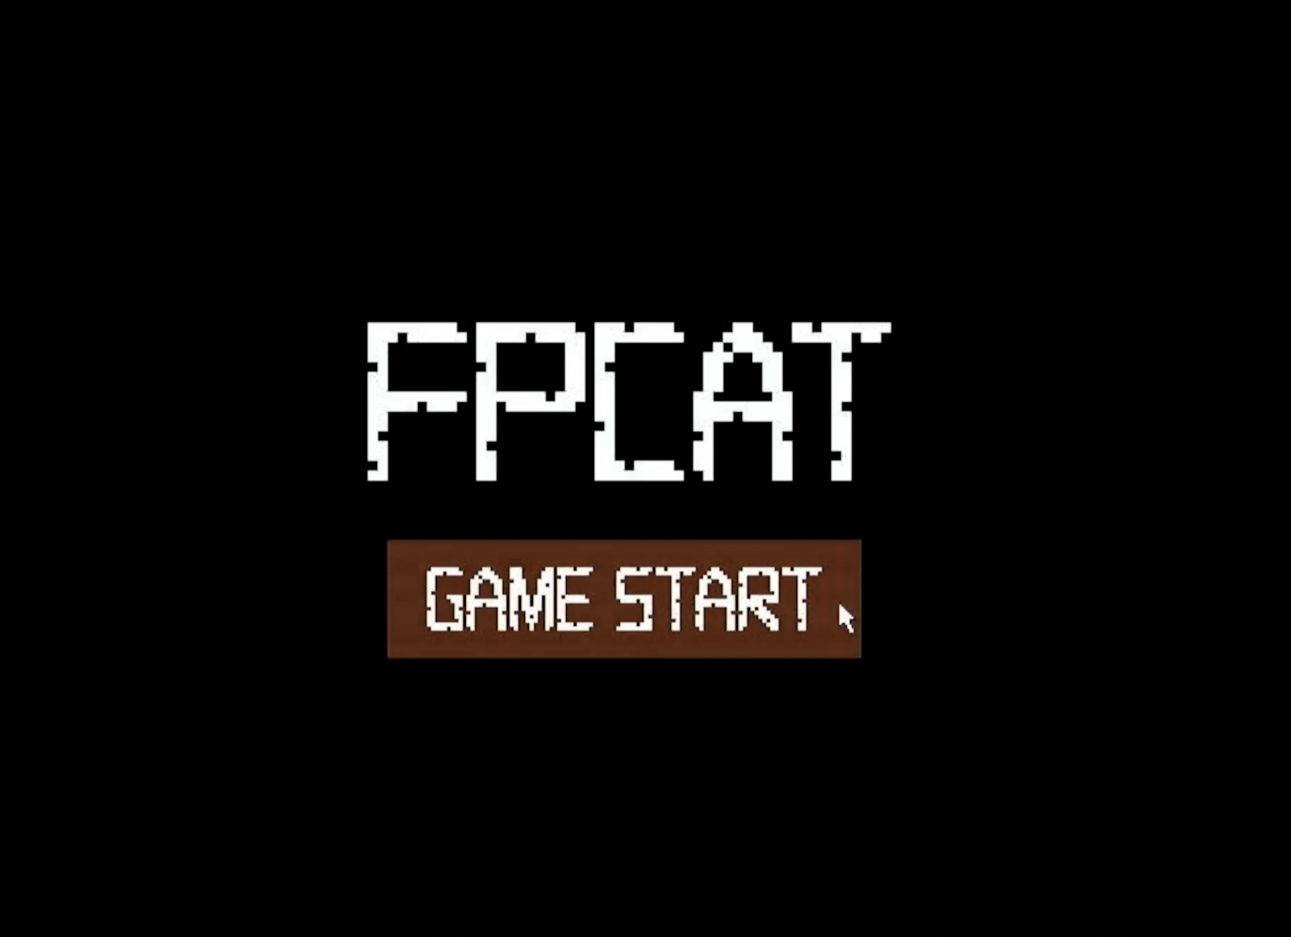We designed separate Start Scene and Menu Scene components based on our reference game Battle Cat, which features an initial game start button before entering the main menu. We decided to keep this design element as it provides a clear game entry sequence for players.

▲ Figure 2.2: Screenshot of Start and Menu Scene of ours and Battle Cat

Additionally, both scenes feature interactive buttons with hover effects - when the mouse cursor hovers over a button, its color changes to provide visual feedback to the player.

## 2.2 Play Scene

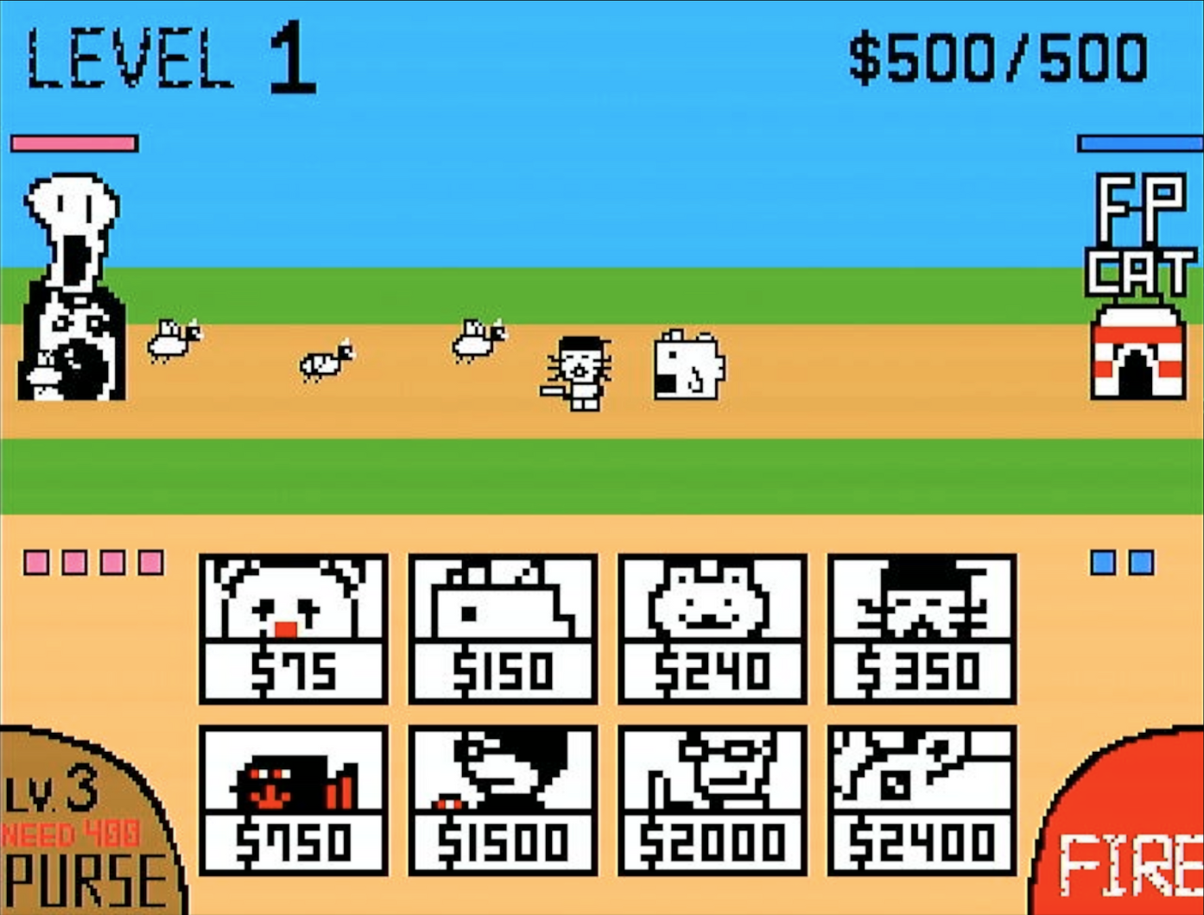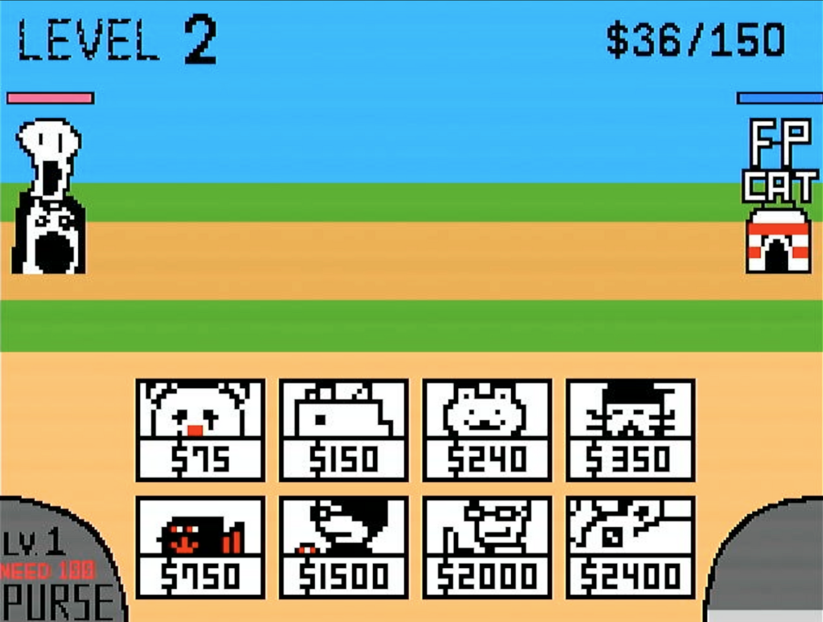Below is our game interface. We will explain each implemented feature in detail.

▲ Figure 2.3: Screenshot of Play Scene

* The Stage number is displayed in the top-left corner, indicating the current level.
* The top-right corner shows both our current money and maximum money capacity.
* In the bottom-left corner is the purse upgrade button. The Purse Level affects both the money generation rate and the maximum money capacity. The button appears gray when there's insufficient money for an upgrade and brown when an upgrade is available. The button displays both the current level and the cost for the next upgrade. The current money will also be displayed on Seven Segment Display.
* The bottom-right features the tower firing button. When fully charged, it shows a red "ready-to-fire" state. After firing, it turns dark gray and gradually transitions to light gray in segments as it recharges. This charging mechanism pays homage to the original Battle Cat game.
* Our tower is positioned on the right side with its HP displayed in blue, while the enemy tower is on the left with HP shown in red.
* The character deployment buttons are located at the bottom of the screen. Unit deployment is only triggered if sufficient money is available. When a unit is deployed, money is deducted and a cooldown effect appears on the button to prevent rapid consecutive deployments of the same character.
* Enemy unit deployment follows a pre-designed Enemy Queuing system, which will be detailed in Chapter 3.2.
* The red and blue little blocks on the sides of the screen indicate the current number of enemy and army (our cats) on the battlefield respectively (this information is simultaneously displayed on the FPGA's LED display). Both sides are limited to a maximum of 8 units on the field at any time. When this limit is reached, no additional units can be deployed. These frames serve as visual indicators, flashing when the 8-unit limit is reached to alert players that they cannot deploy more units, or that enemy unit deployment has been temporarily paused. When one or more enemy units are defeated, multiple new enemy units may be spawned simultaneously, potentially creating challenging combat situations.
* The battle between both sides takes place on a one-dimensional line. However, to prevent complete overlap of all unit layers during multiple-unit combat, units are randomly offset upon generation. All attack and detection calculations remain one-dimensional. This mechanism aligns with the original game Battle Cat.

## 2.3 Win and Lose Scene

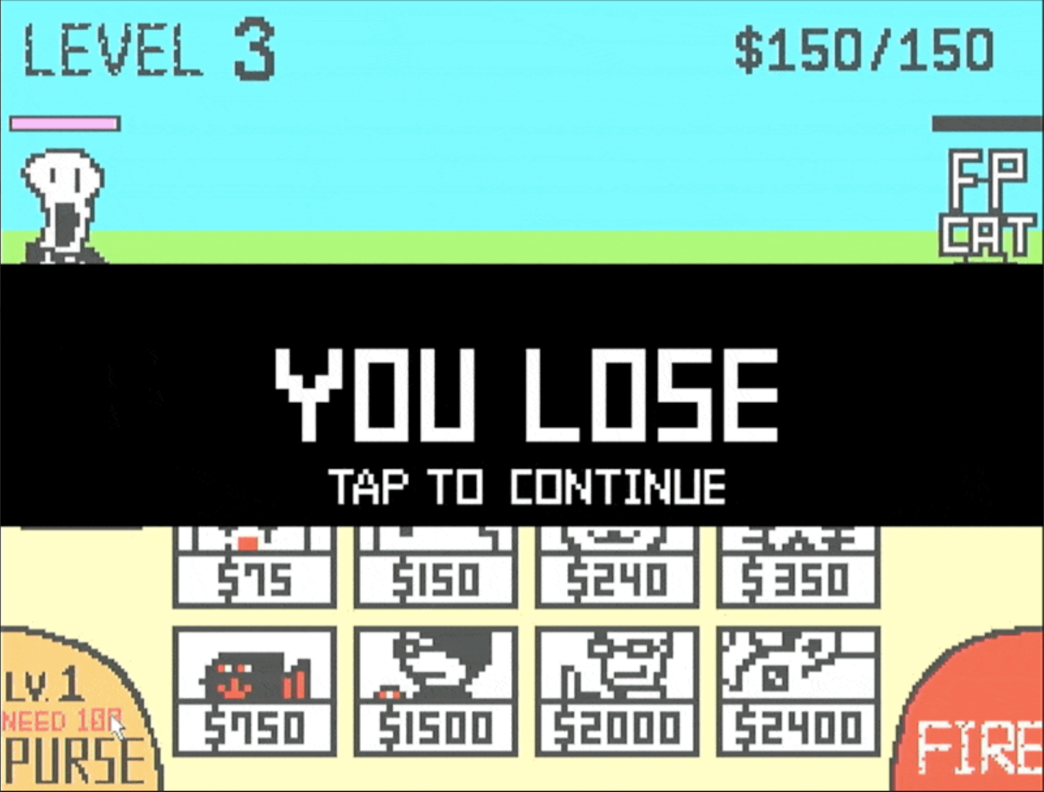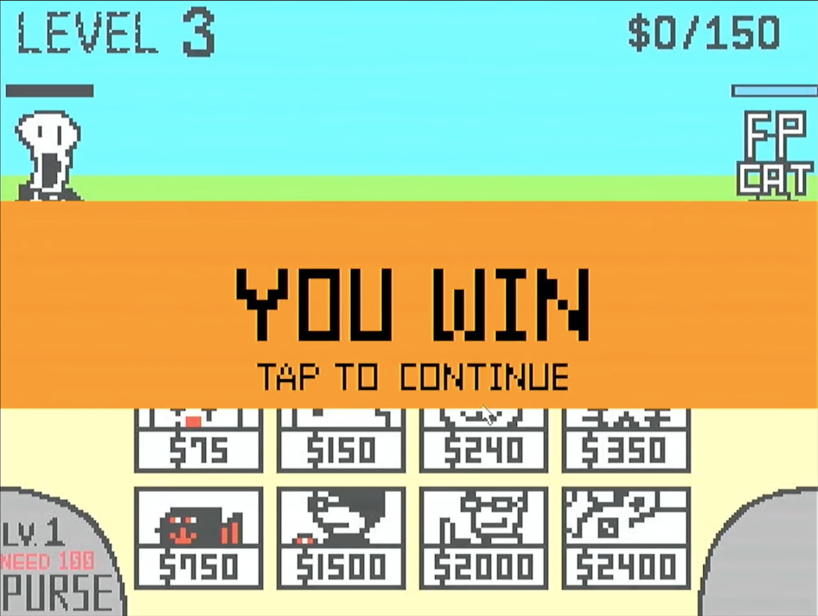For these two scenes, we overlay a horizontal bar on the game screen displaying the win/loss text. A flashing "Tap to Continue" prompt is added to inform players they can return to the Start Scene. Notably, in addition to the horizontal bar, we invert the colors of the final game screen behind the bar to emphasize it.

▲ Figure 2.4: Screenshot of Win/Lose Scene

# 3. Game Material Design

## 3.1 Static Object Design

We utilize IPs (Single-port RAM) to store 19 Static Objects, including:

* 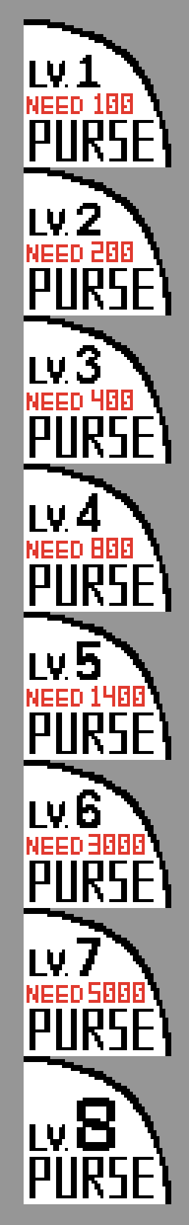Text Elements: 6 instances (mem_FPCAT, mem_LEVEL, mem_GAME_START, mem_YOU_WIN, mem_YOU_LOSE, mem_TAP_TO_CONTINUE)
* Numerical Elements: 2 instances (mem_Numbers, mem_Money_Max)
* Control Buttons: 2 instances (mem_Btn_Purse, mem_Btn_Fire)
* Generation Buttons: 8 instances (mem_Frame_...)
* 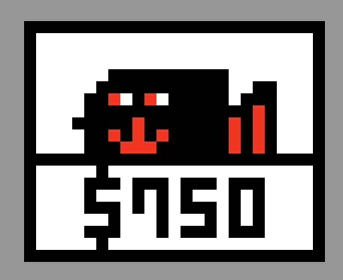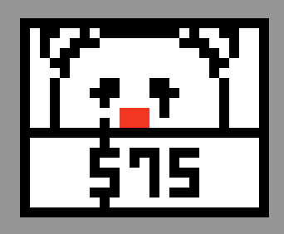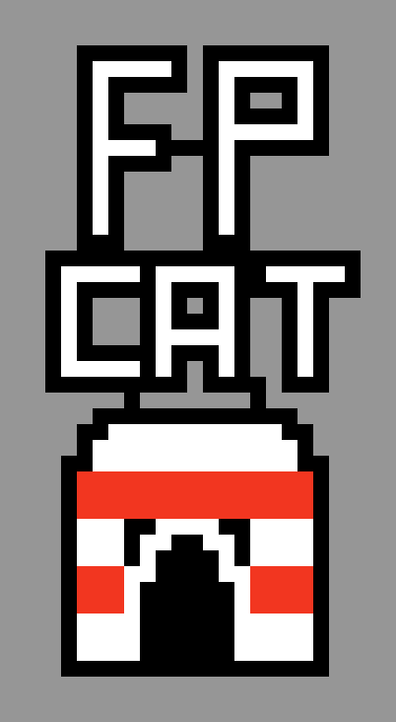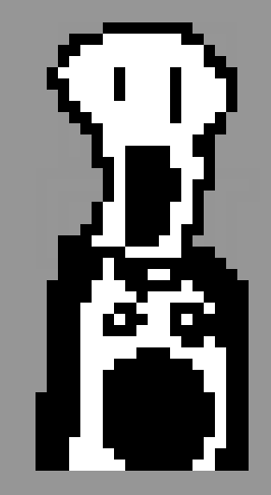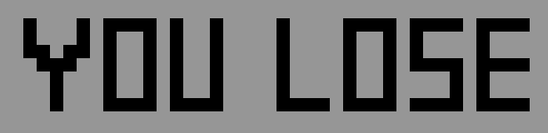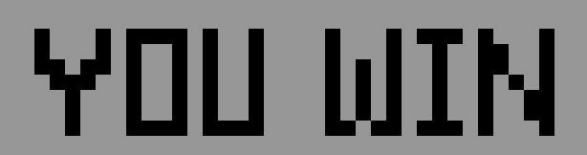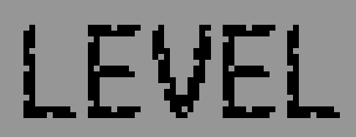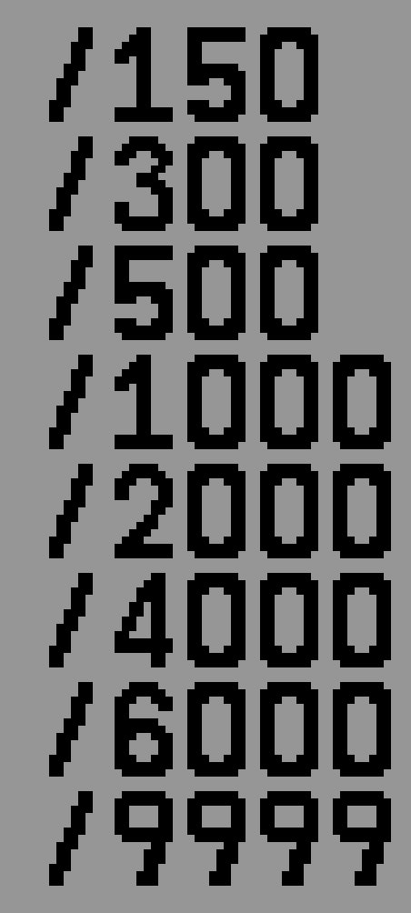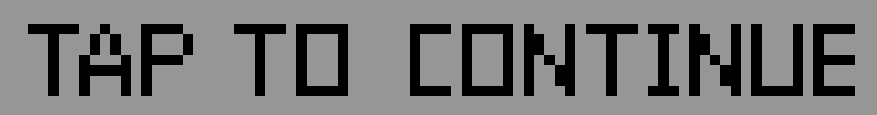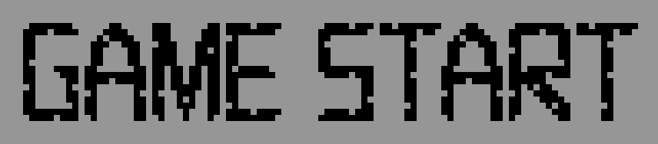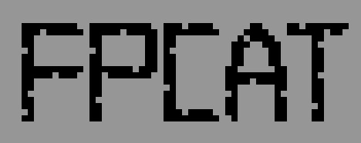Towers: 2 instances (mem_Tower_Cat, mem_Tower_Enemy)

5 more …

▲ Figure 3.1: Self-Designed Static Objects

These elements were all designed by us and converted to **coe** files using Python scripts (See Appendix A.2 for details) to serve as initial values for the RAM modules (these Static Objects' RAM values remain constant and are used solely for rendering purposes).

To optimize storage requirements, all coe files storing images, including the characters mentioned in Chapter 3.2, were converted from PNG format using two methods. The first method, applied to single-color images, uses one bit per pixel to represent either colored or transparent states. The second method, used for three-color images such as characters, towers, and buttons, employs two bits per pixel to represent four states: black, white, red, and transparent. These approaches reduce the storage requirement from 12 bits per pixel (RGB) to either 1 or 2 bits per pixel.

## 3.2 Character Design

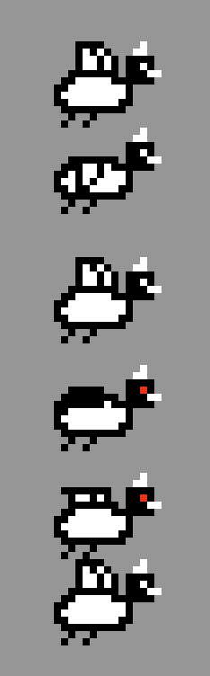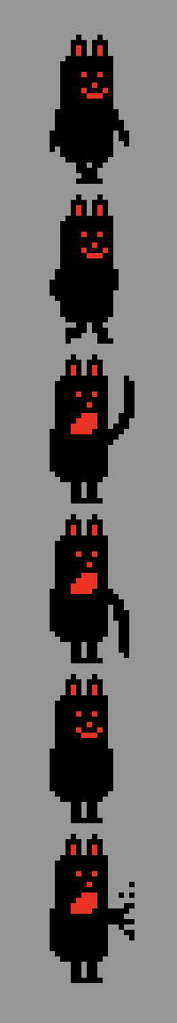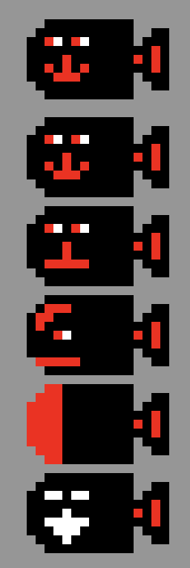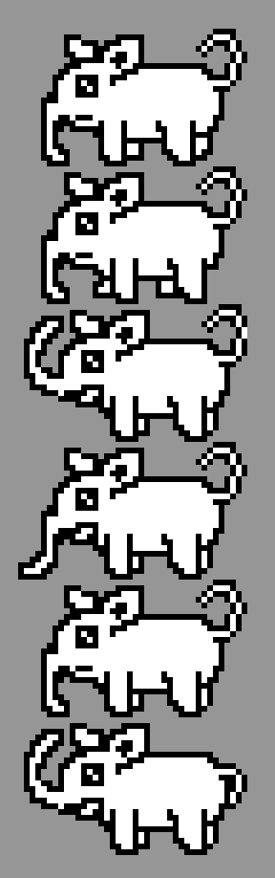We designed 6 images for each character, corresponding to five states: the first two represent the move state, the third to fifth correspond to atk0-1, atk2, and atk3, respectively, and the sixth represents the repel state. A decoder determines the image to access based on the character's state. Since character heights vary, another decoder called Pixels can be used to retrieve width, height, and difference (used for range detection) based on character type. The picture size (height × width) is multiplied by the picture number to calculate the correct address, which is then used to render the character's state via the IP memory module.

**VS**

▲ Figure 3.2: Example for 6 Images for Each Character

While all characters in the game are original designs, some pay tribute to Battle Cats. For example, the enemy Black Bear is inspired by a classic character from the original game, known for its speed, high attack, and low health. In FPCATS, it’s less powerful to reduce game difficulty. Similarly, Bomb Cat is a nod to "Express Cat," sharing its high speed and attack but with slower attack speed.

We also added CS-themed characters like Elephant Cat (a classmate’s nickname), Hacker Cat, and CY Cat (named after a professor).

Below are all the character illustrations we designed:

|  |  |  |  |  |
| --- | --- | --- | --- | --- |
| Army  (Cats) |  |  |  |  |
| Joker Cat | Fish Cat | Trap Cat | Jay Cat |
|  |  |  |  |
| Bomb Cat | CY Cat | Hacker Cat | Elephant Cat |
| Enemy |  |  |  |  |
| Killer Bird | White Bear | Metal Duck | Elephant Cat |

▲ Table 3.1: Character Illustrations

Here is some short introduction of each of the characters:

* Joker Cat: a mass-produced disposable unit with low health but very low cost.
* Fish Cat and Trap Cat: mass-produced tank units with high health and relatively low cost.
* Jay Cat: a long-range damage dealer with low health but decent range and attack power.
* Bomb Cat: an Express Cat having high speed and high damage but with slower attack speed and lower health
* CY Cat and Hacker Cat: versatile mid-range damage dealers. While their range isn't the longest, their attack power is very high.
* Elephant Cat: a tank damage dealer. It has a longer range than mass-produced tanks, very high health, and decent attack power.
* Killer Bird: a standard small enemy, similar to goblins in an isekai setting.
* White Bear: a typical monster that often gives beginners a tough time.
* Metal Duck: a boss-level enemy.
* Elephant Cat: a tanky damage dealer. It has a longer range than mass-produced tanks, very high health, and decent attack power.

Below are the stats for FPCATS characters:

|  |  |  |  |  |  |  |  |  |
| --- | --- | --- | --- | --- | --- | --- | --- | --- |
|  | Joker Cat | Fish Cat | Trap Cat | Jay Cat | Bomb Cat | CY Cat | Hacker Cat | Elephant Cat |
| **HP** | 300 | 600 | 1500 | 400 | 300 | 800 | 1400 | 3500 |
| **ATK** | 30 | 50 | 40 | 140 | 280 | 200 | 180 | 100 |
| **ATK CD** | 8 | 8 | 15 | 12 | 15 | 12 | 12 | 15 |
| **Speed** | 2 | 1 | 3 | 3 | 8 | 1 | 1 | 1 |
| **Range** | 15 | 10 | 5 | 40 | 5 | 35 | 35 | 20 |
| **Price** | $75 | $150 | $240 | $350 | $750 | $1500 | $2000 | $2400 |

|  |  |  |  |  |
| --- | --- | --- | --- | --- |
|  | Killer Bird | White Bear | Metal Duck | Black Bear |
| **HP** | 400 | 1500 | 4000 | 140 |
| **ATK** | 40 | 140 | 100 | 80 |
| **ATK CD** | 10 | 15 | 15 | 3 |
| **Speed** | 1 | 1 | 1 | 8 |
| **Range** | 10 | 20 | 10 | 20 |

▲ Table 3.2: Character Statistics

Speed is measured in pixels/clk_6, range in pixels, and atk_cd in clk_6 units. For detailed specifications, please refer to Chapter 4.

It is noteworthy that while the Black Bear's attack power appears low, its short atk_cd results in a DPS (damage per second) that is four times higher than that of the Metal Duck.

## 3.3 Stage Design

- IPs for enemy queue

# 4. Game Engine

First, we will explain the main clock signals utilized in our system:

|  |  |  |
| --- | --- | --- |
| Signals | Relationship | Descriptions |
| clk | from FPGA | System Clock (100MHz) - This is primarily used to generate the 25MHz clock signal. |
| clk_25MHz | clk / 4 | Our main operational signal is the clock required for VGA to generate 640x480 60Hz output with buffer time. During the rendering phase, each pixel's color code is designated within one this clock cycle. Consequently, this clock signal is used for both our game engine operations and mouse input detection. |
| clk_frame | clk_25MHz / 800 | This is a signal indicating a frame update, which is mainly used to generate clk_6. |
| clk_6 | clk_frame / 9 | The signal was initially named clk_6 as we aimed to achieve 10 updates per second, which would be 60Hz divided by six. However, during game testing, we found this frequency to be too rapid, so we modified it to divide by nine instead. This frequency-divided signal is primarily used for Game Engine updates, facilitating the management of character movement and attack intervals. It serves as the main update clock for counters within the Game Engine. |

▲ Table 4.1: Clock Signals

In the game scene, we divide the game process into two parts based on VGA protocol characteristics. VGA requires blanking time at the end of each line to pull back the pointer to the line's beginning, and corresponding blanking time after completing an entire frame. In our project, while the final output is 640x480, the pixel_cnt and line_cnt in the VGA Module run up to 800x525. We utilize this non-output time period, specifically when line_cnt equals 490, to start processing the game engine operations.

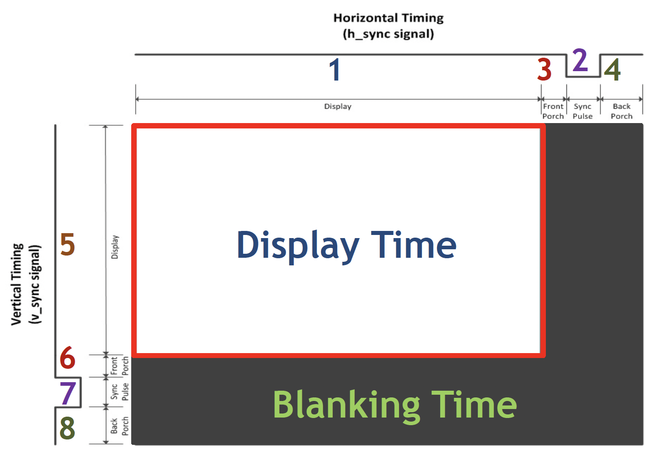▲ Figure 4.1: VGA Sync Process

## 4.1 Storage Protocols

First, we'll introduce the main protocols used. In addition to the previously mentioned three Enemy Queues that use 15 bits for timestamp and 3 bits for enemy type, below are several key protocols. Instances are implemented as a register, with Army and Enemy each having space for 8 Instances. The other two components, Stats and Pixels, are decoders that output corresponding data based on the input Army/Enemy Type (3 bits).

The state, state_cnt and be_damaged in **Instances** will be explained later in this chapter. **Stats** information has been previously explained in Chapter 3.2. **Pixels** stores each character's Width, Height, and Difference values. Difference represents the offset from the image boundary to the character's actual body, used for precise range detection, which will be explained in Chapter 4.3.

## 4.2 Character FSM

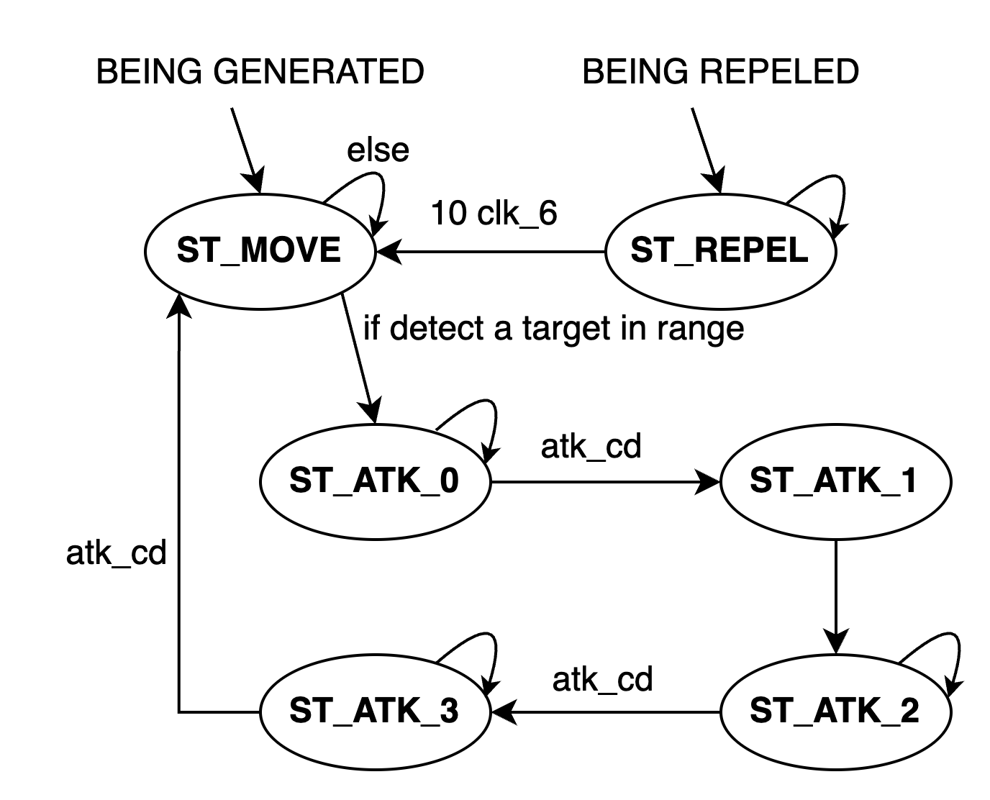Before explaining the overall Game State operation, we'll introduce the character FSM.

▲ Figure 4.2: Character FSM diagram

Each character has 6 states, beginning in ST_MOVE state upon generation. In this state, the character moves a specified number of pixels based on its speed value during each game engine update (clk_6). When detecting an enemy within its attack radius, it enters ST_ATK_0 and waits for atk_cd clock cycles before transitioning to ST_ATK_1. Both these states use the third image, representing the attack wind-up animation. ST_ATK_1 lasts for only one clock cycle and executes attacks on opponents, including towers, within the attack radius. The attack is recorded in the target's be_damaged field. Subsequently, the character transitions through ST_ATK2 and ST_ATK_3, using the fourth and fifth images respectively, representing the attack animation and follow-through. Finally, it returns to ST_MOVE, awaiting movement or the next attack sequence.

Operating independently from this cycle is ST_REPEL, triggered by two events: when the character's health drops below half, or when an Enemy is hit by our air cannon. During these ten clock cycles, the character is knocked backwards, after which it returns to ST_MOVE. Besides, the mechanism of knockback upon receiving damage at half health is also derived from the original game Battle Cats. This feature not only allows for strategic manipulation of battle lines through enemy knockback but also serves as an indicator of a character's approximate current health status.

## 4.3 Game State FSM

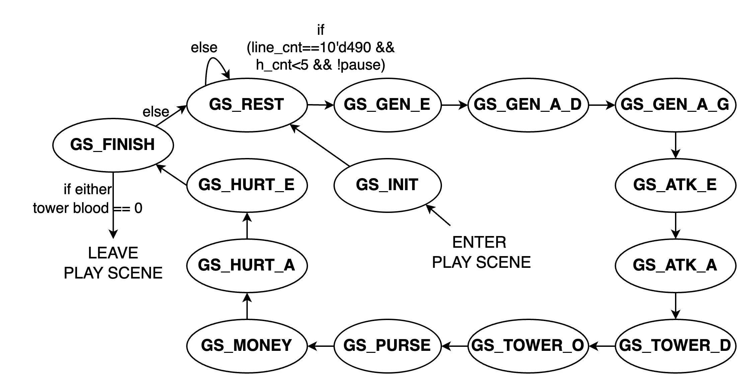This chapter explains the core operation of the game system. As previously mentioned, the game engine detection timing is based on the clk_25MHz signal with a clk_6 frequency divider, which determines the update frequency for character movement, attacks, money accumulation, tower cooldowns, and other game mechanics. The game's core functionality relies on the interactions between Army_Instance, Enemy_Instance, Enemy Queue, and various buttons. Below is the FSM Diagram of our Game State.

▲ Figure 4.3: Game State FSM diagram

Next, we will explain the operation of each Game State:

* **GS_INIT**: When a player selects a Stage to enter the game, it first enters this state. Within one clock cycle, it initializes all signals, including resetting the exist flag of both sides' Instances to 0, restoring both towers to full health, resetting money to zero, etc., before proceeding to GS_REST.
* GS_**REST**: This is the state where the system remains after completing a game operation round. It performs no actions and waits for the next round to begin, which occurs only when clk_6 is active, line_cnt reaches Blanking Time, and the pulse switch isn't activated. This implements the pause functionality, which is particularly crucial for experienced Battle Cats player Chia Chin, as it allows players to pause and strategize.
* **GS_GEN_E** (Generate Enemy): This state generates enemies according to the designed Enemy Queue. The game uses a game_cnt as a counter for the overall game progress and a pointer indicating the next generation line. When game_cnt matches the timestamp pointed to by the pointer, it searches for available positions in Enemy_Instance. If a position is found, it generates a new entity based on the Enemy_Stats Decoder output and moves the pointer to the next line. If all eight entities exist, no generation occurs and the pointer remains static until the next detection when a position becomes available.
* **GS_GEN_A_D** (Generate Army Detection): This single clock cycle state determines whether to generate ally characters (cats), checking for button clicks, sufficient money, and completed cooldown times. The result is passed to the next game state.
* **GS_GEN_A_G** (Generate Army Generation): Receives generation requirements from the previous state. If none exist, it advances to the next state in the following clock cycle. If requirements exist, it searches for available generation positions. Upon finding a position, it deducts money and initiates the button cooldown. If no position is found, the generation attempt is nullified and no action will be applied.
* **GS_ATK_E**, **GS_ATK_A**: These states update each character's state based on their current character state, such as ST_MOVE's detection for attack or movement. Range detection utilizes Pixels' Difference for consistent attack range starting points, ensuring proper front-back relationships during combat as designed. Other aspects have been described in Chapter 4.2 and won't be repeated here.
* **GS_TOWER_D** (Tower Detection): Similar to GS_GEN_A_D, it checks if the tower's fire button is pressed and cooldown has ended, passing results to the next state.
* **GS_TOWER_O** (Tower Operation): Sequentially checks Enemy_Instance for entities within the tower's fire range. If found, applies damage and changes their character state to ST_REPEL for knockback effect.
* **GS_PURSE**: Checks if the Purse Level upgrade button is pressed, funds are sufficient, and current level hasn't reached maximum. If all conditions are met, deducts upgrade cost and increases Purse Level.
* **GS_MONEY**: Simply increases money according to the current Purse Level.
* **GS_HURT_A**, **GS_HURT_E**: Applies the be_damaged values recorded in each Instance to their HP during this update round. If the be_damaged exceeds remaining HP, sets exist to zero, resulting in entity death.
* **GS_FINISH**: Finally, when a round completes and returns to this state, it checks tower health. If either tower's health reaches zero, indicating a decisive outcome, exits the play scene and enters win/lose scene. Otherwise, enters GS_REST awaiting the next update round.

# 5. Graphics Rendering

## 5.1 Rendering Module Architecture

- scene change, tint technique

## 5.2 Layer Implementation

### 5.2.1 Statis Objects

### 5.2.2 Characters

# 6. Conclusion

## 6.1 Gameplay Demonstration

## We will use a video to showcase our actual gameplay, providing a complete demonstration of the various features of our game. This is our YouTube video link.

//TODO: video link

## 6.2 Comparison with Original Game

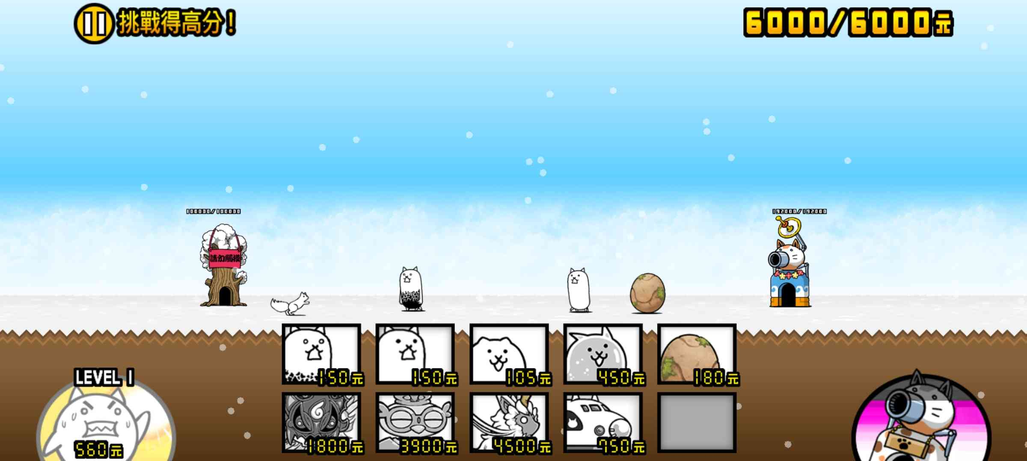 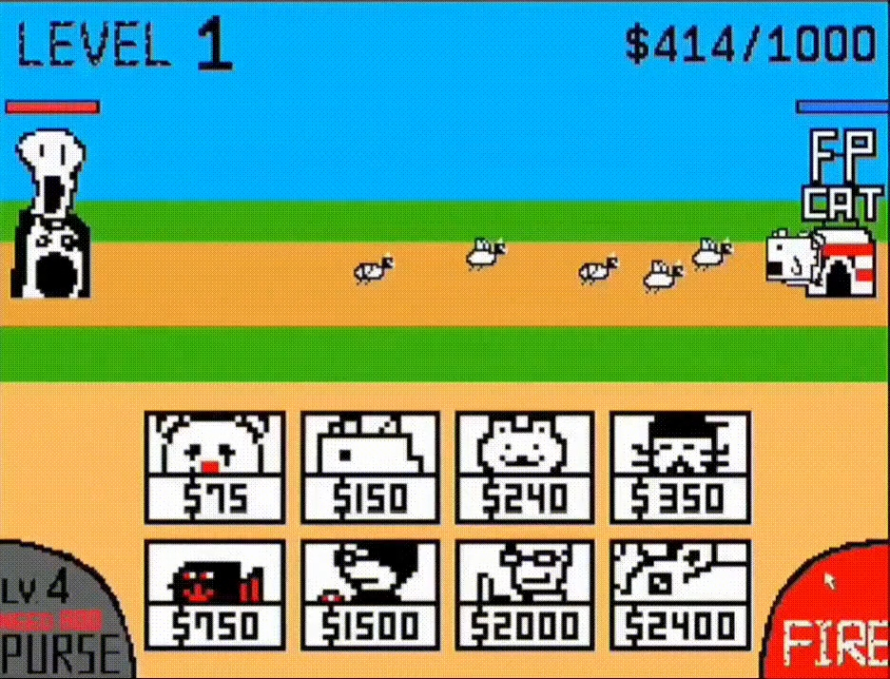

▲Figure 6.2.1: Just showing the screen layout of the original game and our game

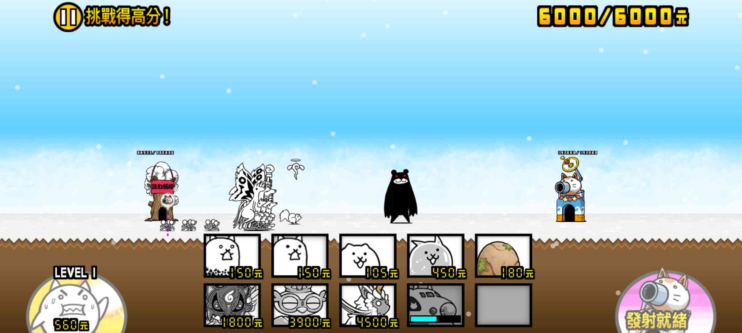 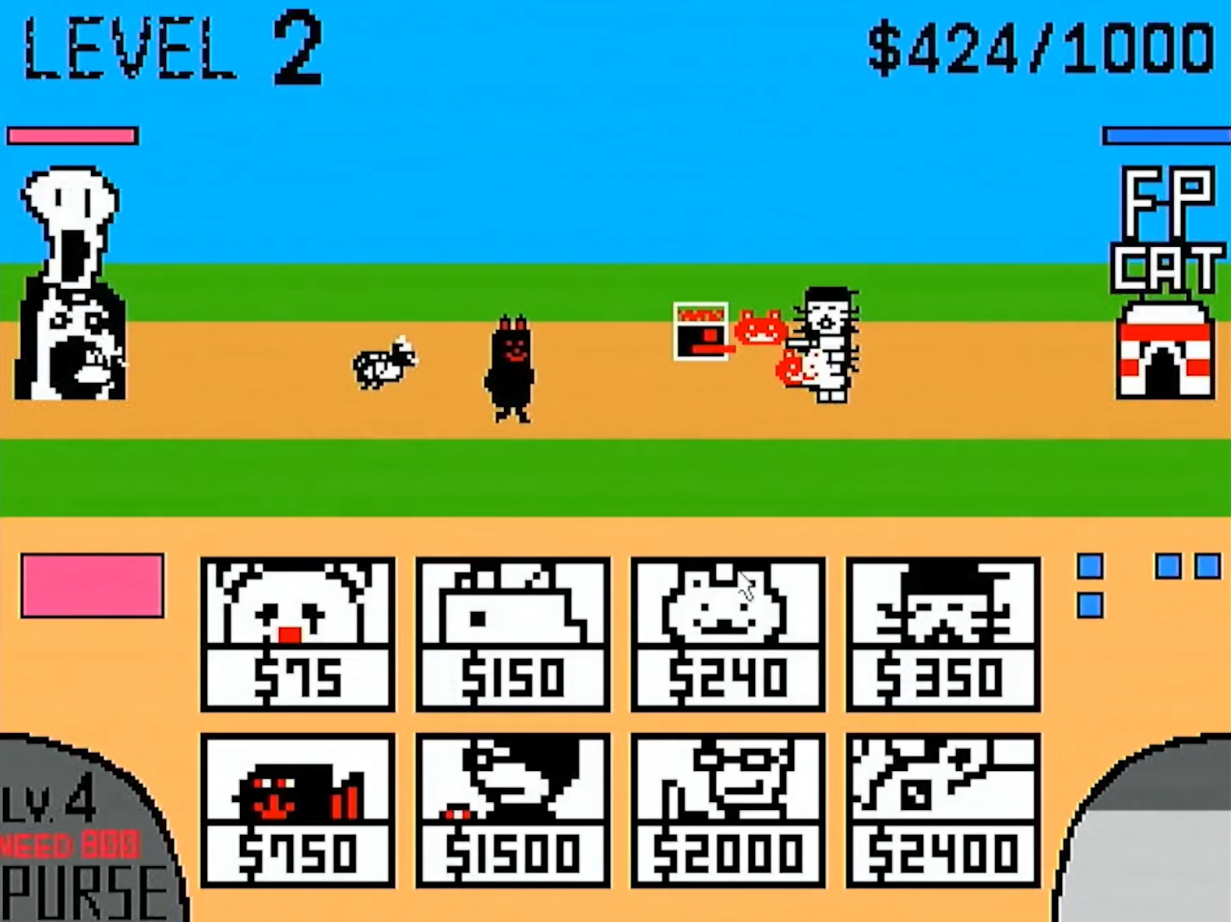

▲Figure 6.2.2: Black bear is coming!!! Watch out!!!

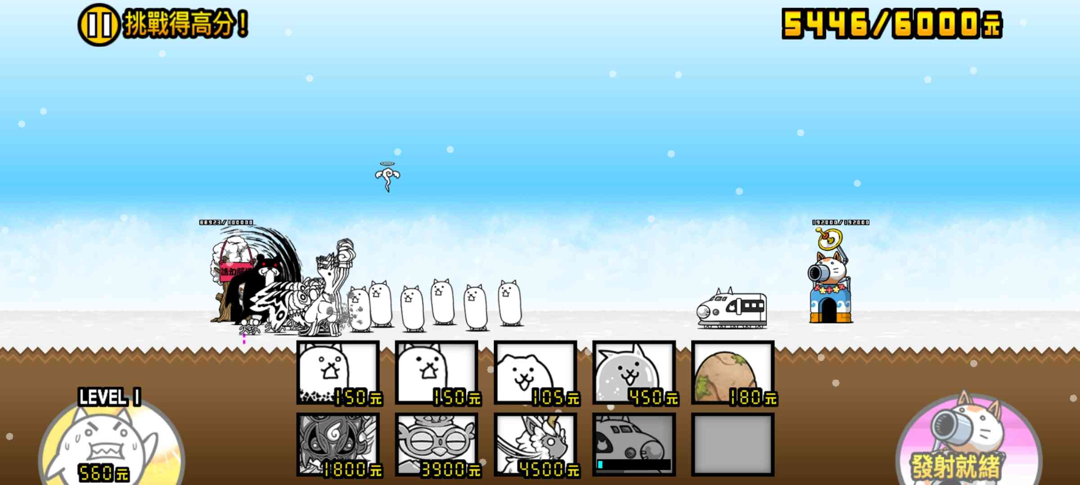 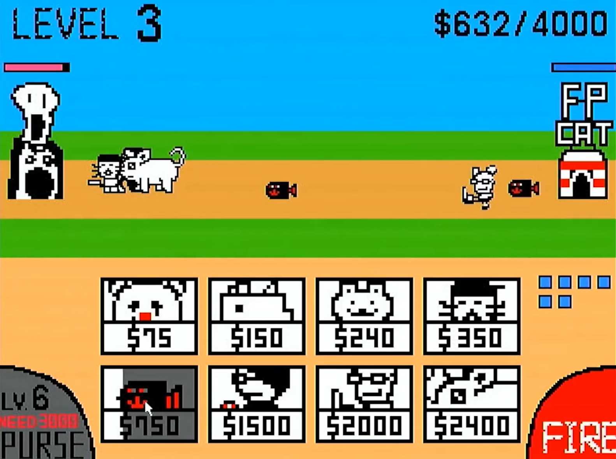

▲Figure 6.2.3: Don’t worry! Bomb Cat(Express Cat) is here.

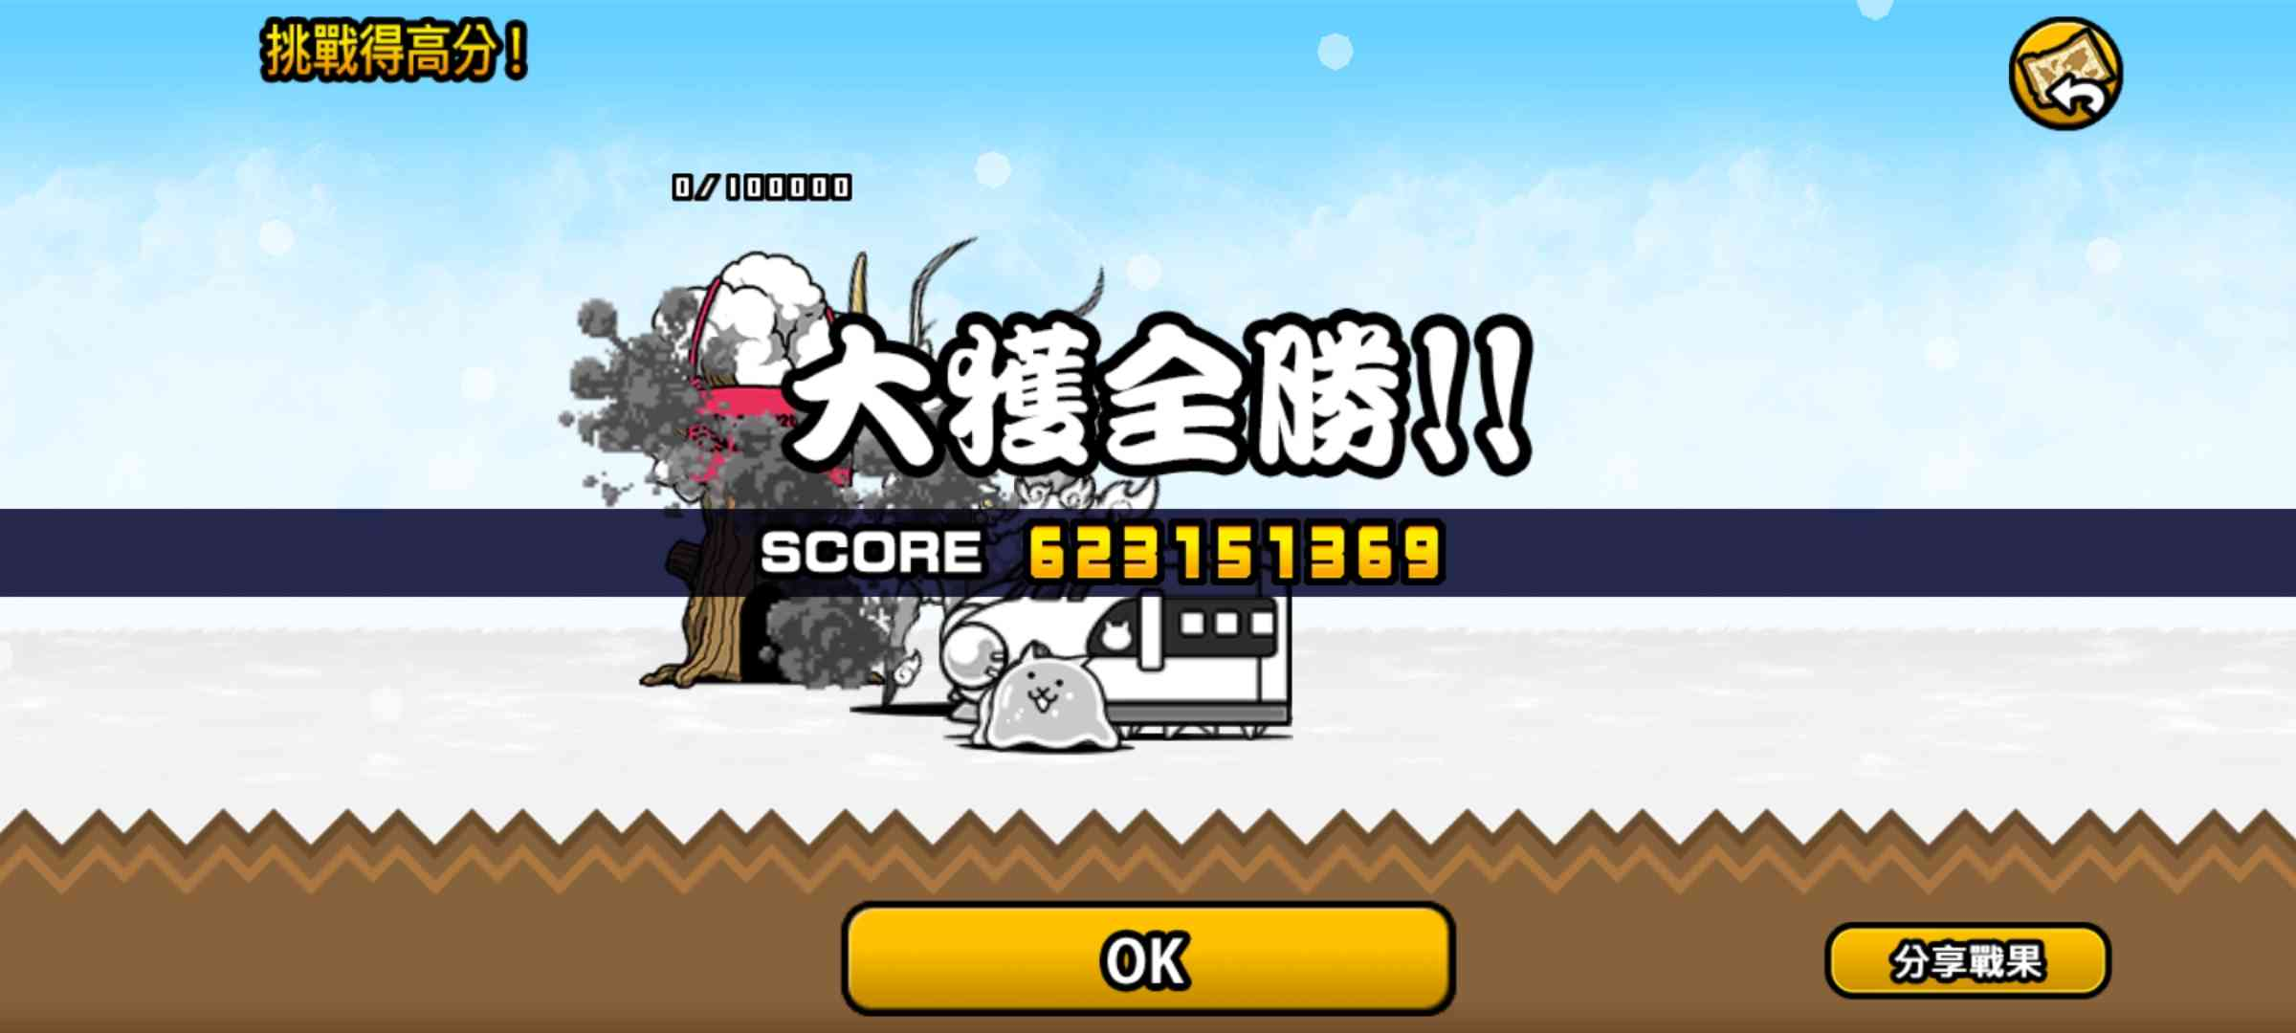 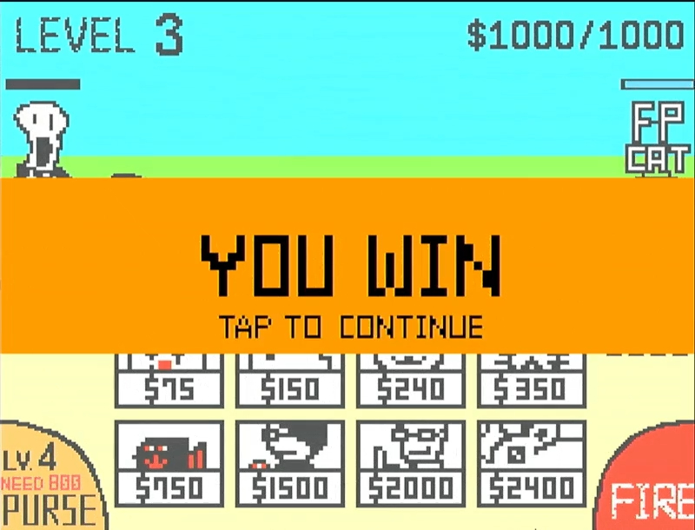

▲Figure 6.2.4: Hehehe! We are winning!

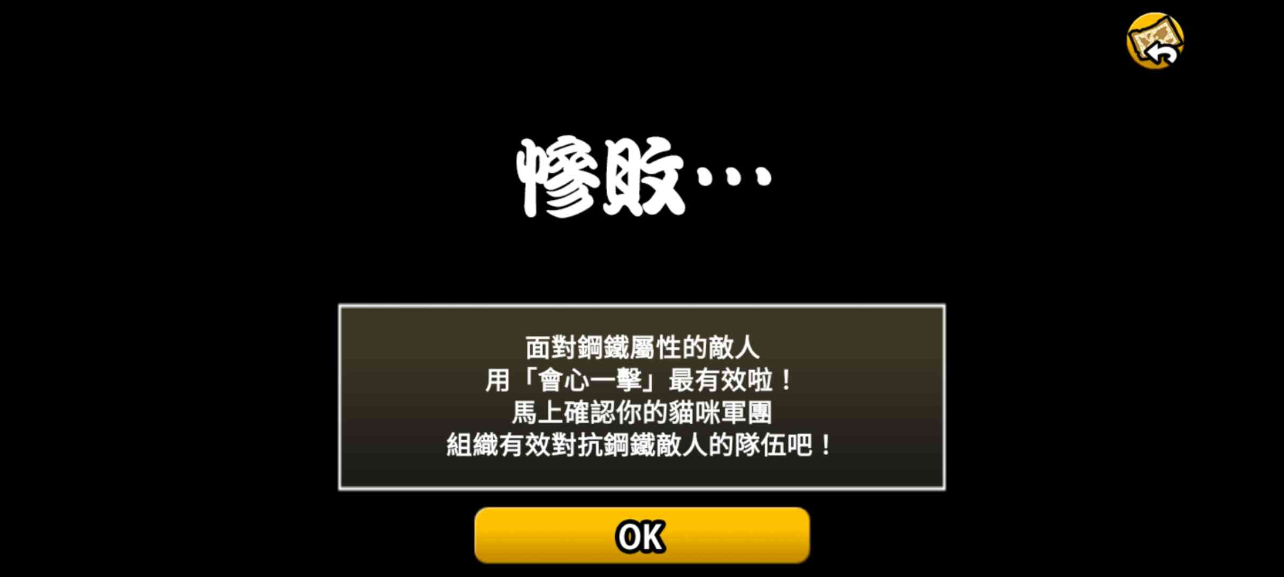 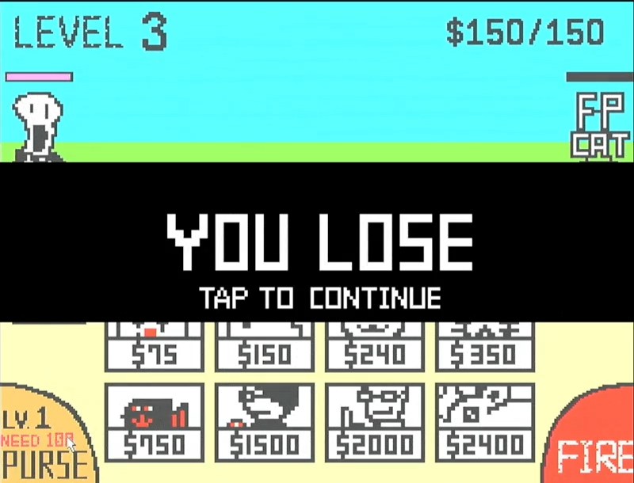

▲Figure 6.2.4: No…

## 6.3 What We Learned

# A. Appendix

## A.1 Contribution

## A.2 Python Tool - PNG to COE